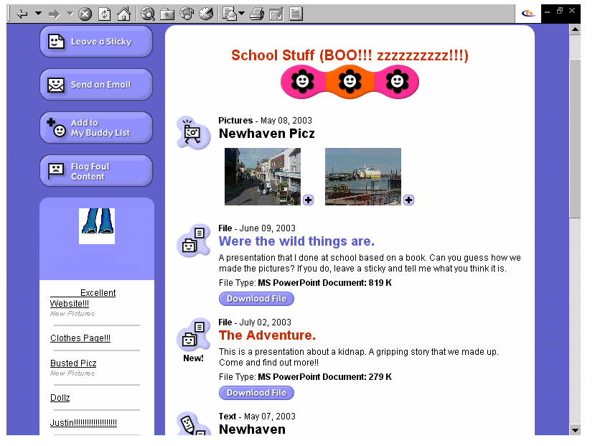
Child’s name removed
Shows contrast between child led activities and teacher-initiated work
Sample Page from A Child’s Website

